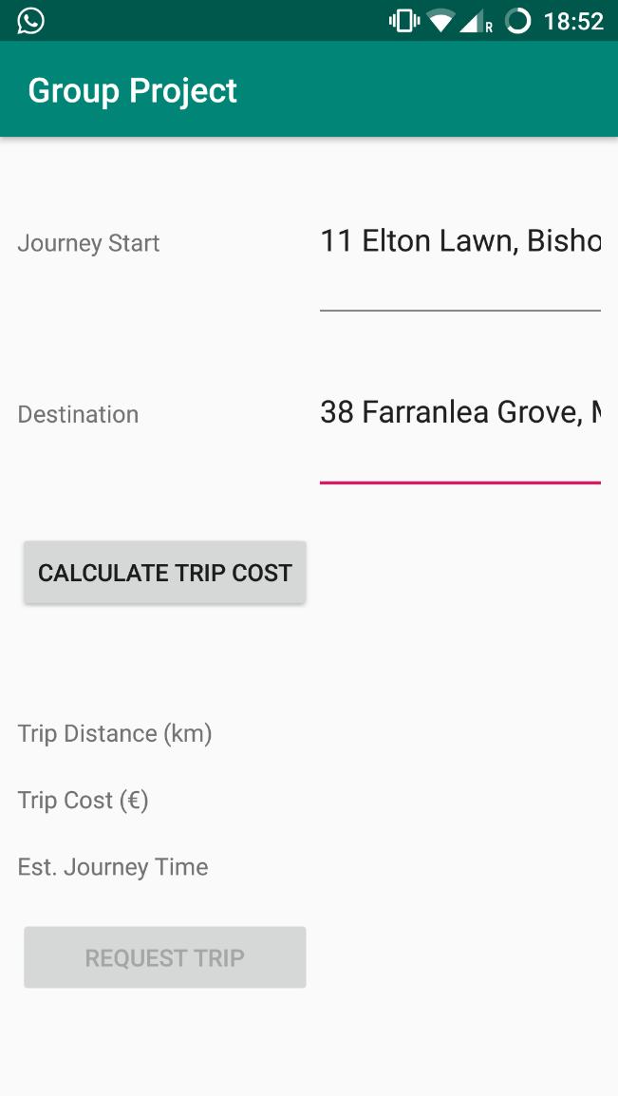Request Form Activity

* Uses autofill text views and the Google geocoding API
* Suggests address based on user input

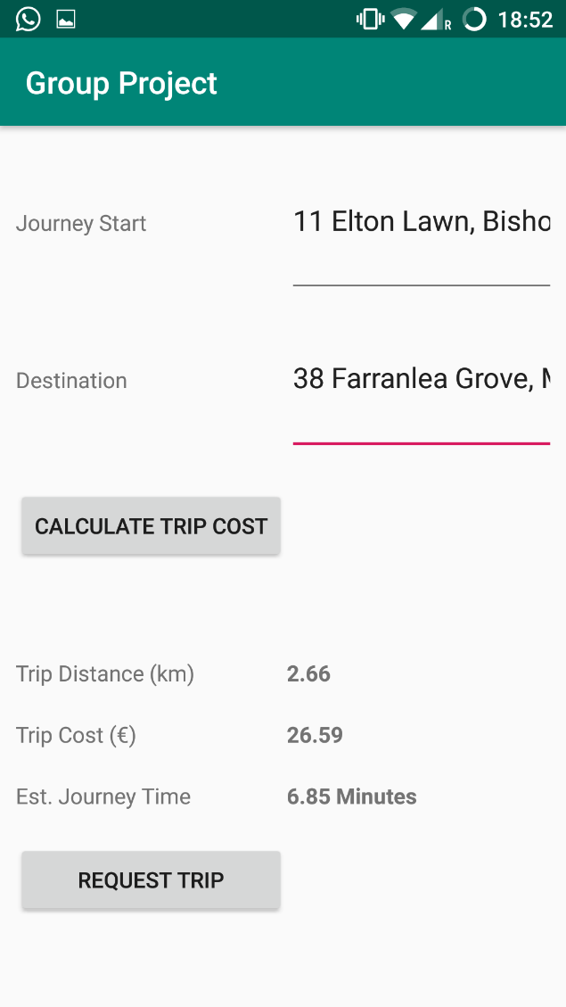

# Request Form Activity

* Uses the Google distance matrix API to calculate trip distance and estimated journey time.
* Price is a set price/km
* Trip can be requested once price is calculated

# Trip Pending Activity

* Trip request is pushed to Firebase live database with a state of pending
* The code listens for changes to the elements of the database and checks if the request has been approved or denied
* User can cancel the request at this point

# Trip Pending Activity

* Admin can refuse to accept the trip and the user will be informed

# Map View Activity

* User will see a live view of the vehicle’s position as it approaches and throughout the journey.

# Map View Activity

* When the vehicle is close to the pickup point, the user will be informed of the vehicles details via notification

# Map View Activity

* Prompt for review when the vehicle reaches the destination.

# Review Activity

* Reviews are tied to the trip ID and pushed to the firebase live database